Prac 8

8a

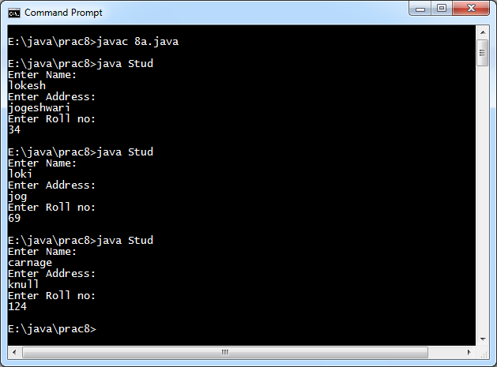

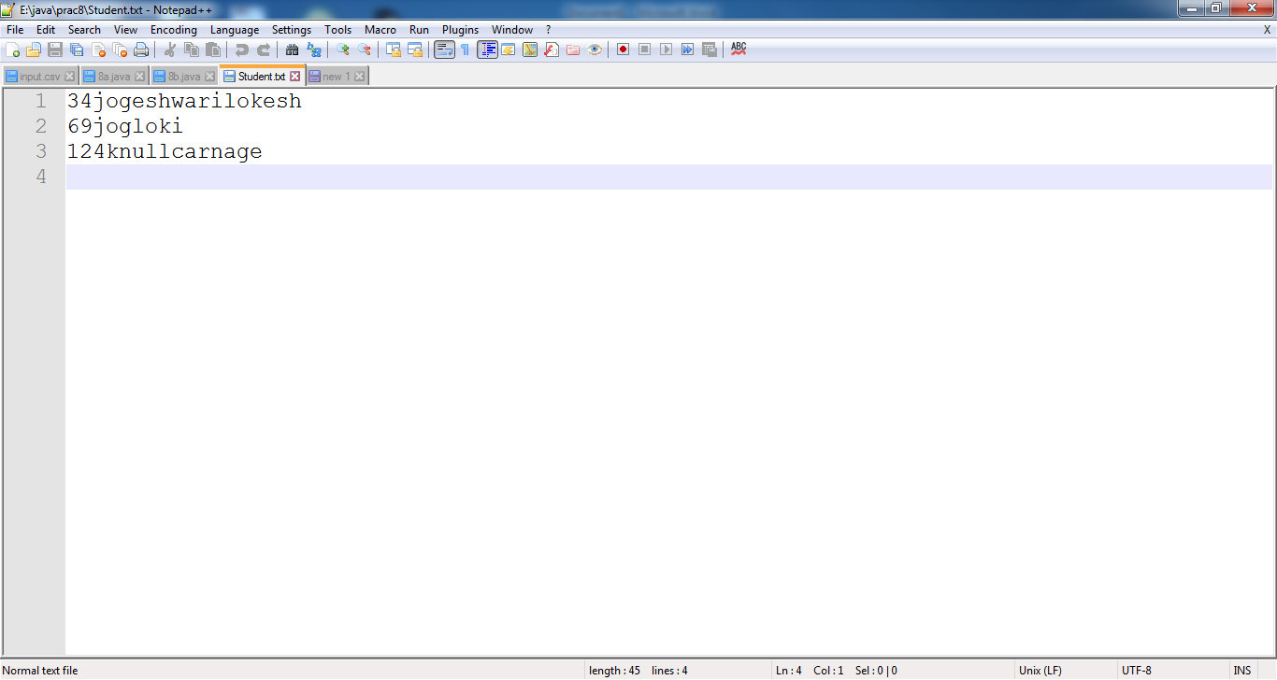

8b

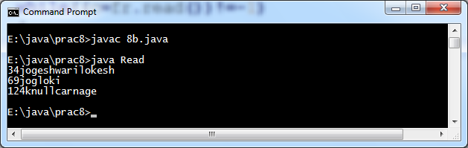

8c

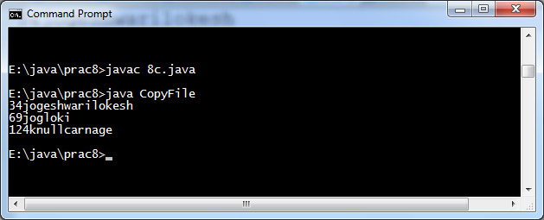

Student.txt

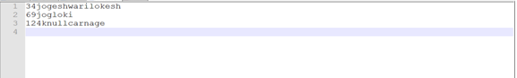

Stu.txt

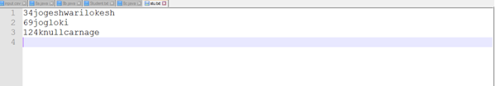

8d

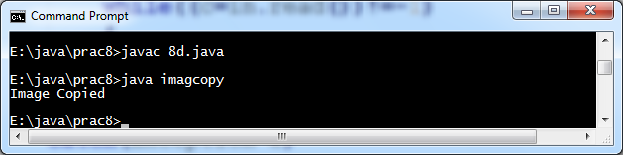

Download.png pop.png

|  |  |
| --- | --- |
|  |  |